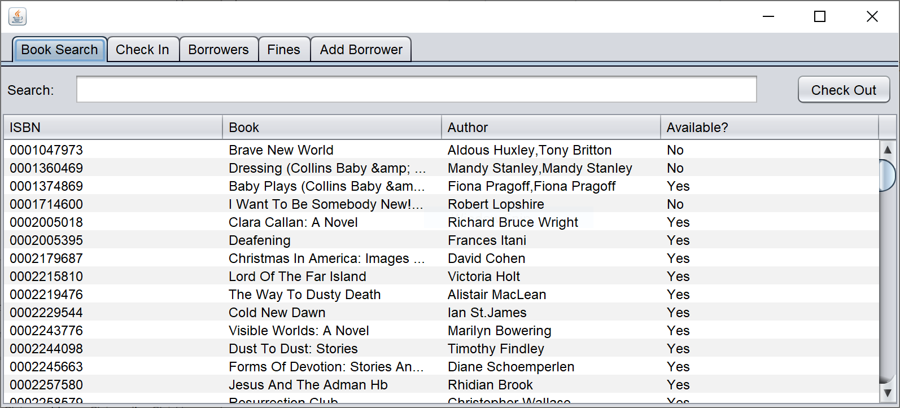

This is the library application. You can see that there are several tabs for control over the individual needs of a library. Here is a step by step walkthrough of how to use this application.

1. In order to check out a book, you must highlight a row and click check out. Once pressed, it will pop up the dialog below. You will enter the borrower card number and the system will then display a message relaying if the book was checked out or if there was a problem. The search bar is linked to the Jtable and will filter the whole table based on what you type in.

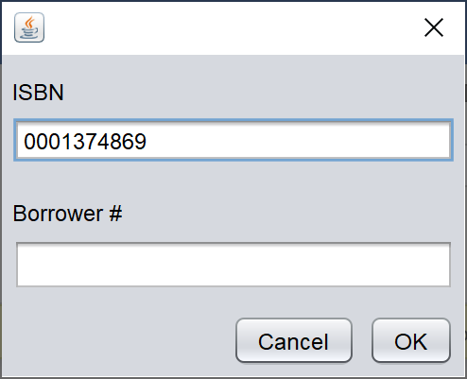

1. The second tab is used to check in books. You must highlight a book(s) and click the check in button. You will receive error messages if there was any problems. The search bar works as the first tab does, it filters the table based off of input.Screen is below.

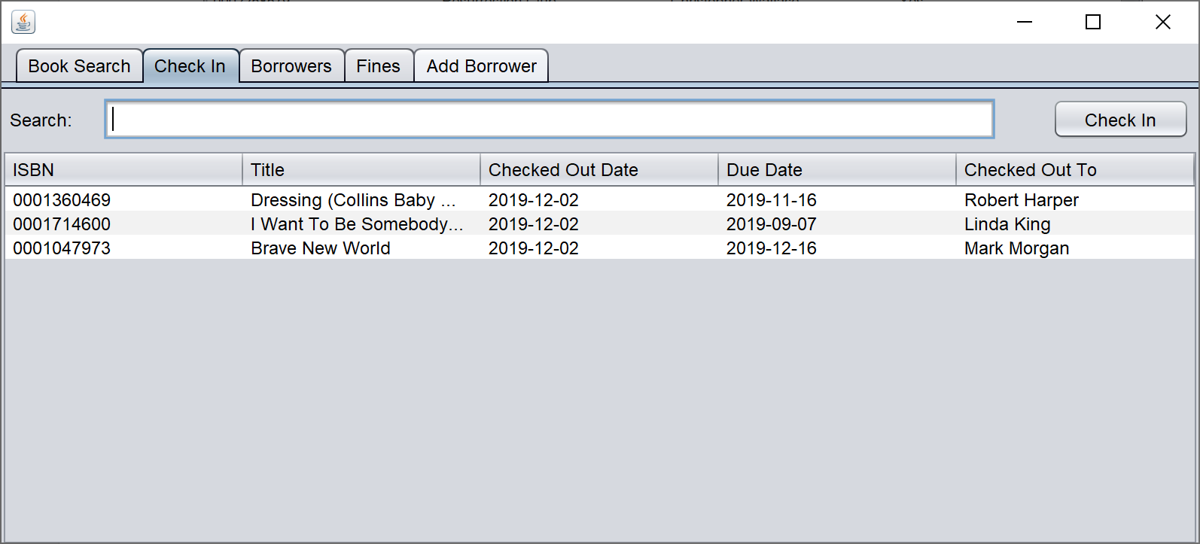

1. The next tab is very simple. It just displays all borrowers in the system and is also able to be filtered by the search bar.

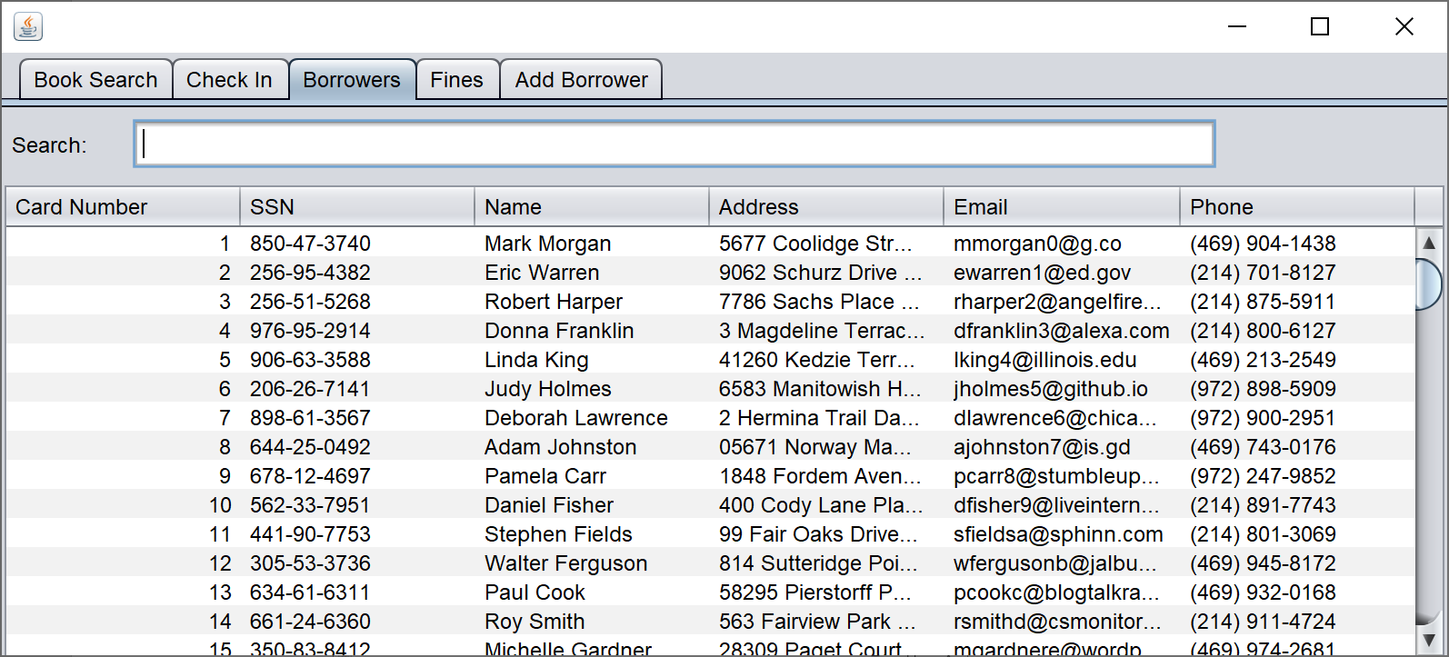

1. The Fines tab displays the fines in the database. You are able to filter by unpaid fines or all fines by selecting the checkbox in the top left. The update fines button will update all fines if they need to be updates. You must highlight a fine(s) to pay a fine. There will be error messages if anything is not able to be paid.

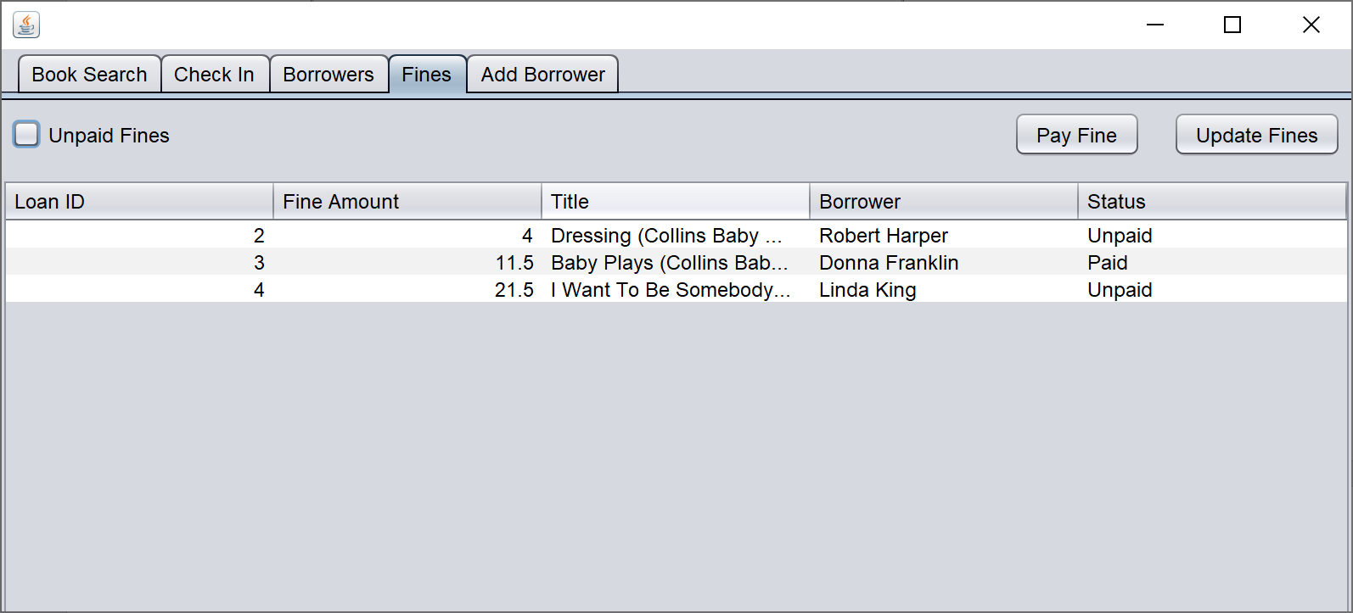

1. The Add Borrower tab is the tab used to add a borrower to the system. You must fill out all fields, and if you do not do correct format, you will receive an error message and the user will not be submitted. Once all fields are filled out, you must press the Add button. After being added, the text boxes will be cleared.

